PYTHON FOR DATA ANALYTICS
COURSE INTRODUCTION
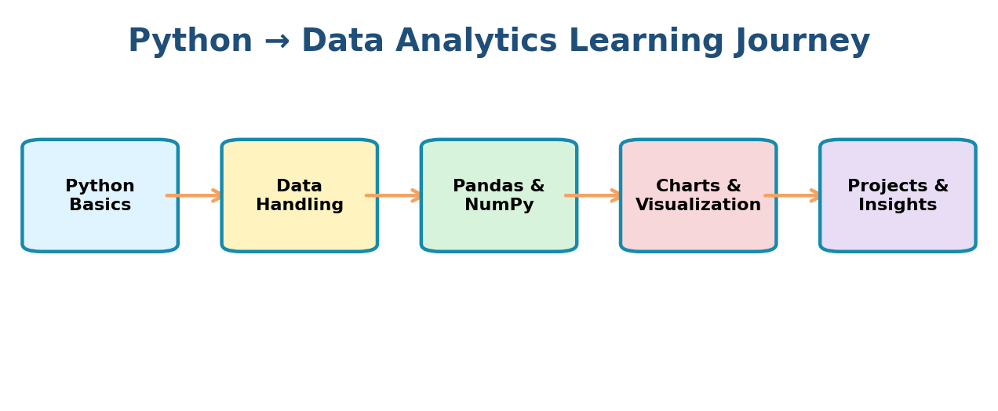
Course Goal
Build a strong Python foundation and gradually use Python to work with data, perform analysis, create visualizations and communicate useful insights.

1. What is Python?
Python is a beginner-friendly programming language used for automation, artificial intelligence, machine learning and data analytics.
print("Hello, Data Analytics!")

2. What is Data Analytics?
Data Analytics is the process of examining data to find useful information, patterns and insights that support better decisions.
- Collect data
- Clean and prepare data
- Analyze patterns and results
- Create charts or reports
- Communicate useful insights

3. Why Python for Data Analytics?
- Easy-to-read syntax for beginners
- Large ecosystem of data and visualization libraries
- Works with CSV, Excel, databases and other data sources
- Useful for automating repetitive data tasks
- Widely used in analytics and AI workflows

4. How Python Fits into Data Analytics
The course follows a practical progression: learn Python fundamentals, work with data, analyze it, visualize it and apply the skills to projects.

5. Tools We Will Use
Tool | Purpose | Beginner Use
Python | Programming language | Write Python programs
VS Code | Code editor | Create and run .py files
Jupyter Notebook | Interactive coding | Run code step by step
Pandas | Data analysis | Work with tables and datasets
NumPy | Numerical computing | Work with numerical data
Matplotlib | Visualization | Create charts and graphs

6. Small Data Analytics Example
Simple Python can calculate useful information from data.
sales = [12000, 15000, 18000, 10000]
total_sales = sum(sales)
average_sales = total_sales / len(sales)
print(f"Total Sales: ₹{total_sales:,.0f}")
print(f"Average Sales: ₹{average_sales:,.0f}")
Later, we will perform similar tasks with real datasets containing many rows and columns.

7. What You Will Learn
- Python fundamentals and programming logic
- Variables, data types, operators and conditions
- Loops and functions
- Files and datasets
- NumPy and Pandas
- Data cleaning and transformation
- Charts and visualization
- Practical analytics projects

8. Common Beginner Mistakes
- Trying to memorize code instead of understanding it
- Ignoring error messages
- Skipping Python basics
- Copying code without testing it
- Not practicing regularly

9. Best Practices
- Type examples yourself
- Run small pieces of code and observe the output
- Practice each concept with a small variation
- Read errors carefully and fix them step by step
- Use meaningful names and organized code
Learning Mindset
You do not need to know everything before starting data analytics. Learn one concept, write code, make mistakes, fix them and gradually build confidence.

10. Key Takeaways
- Python is powerful and beginner-friendly for data analytics.
- Data Analytics turns raw data into useful insights.
- Python provides tools for cleaning, analysis and visualization.
- The course moves from fundamentals to practical analytics.
- Regular coding practice is more important than memorizing syntax.
COURSE INTRODUCTION COMPLETE

